Docker Task-02
- Create a tomcat container on 8080 and deploy sample application in tomcat.
- To create a Tomcat container running on port 8080 and deploy a sample application in Tomcat.
- Step by step implementation
- Launch server and start the docker service

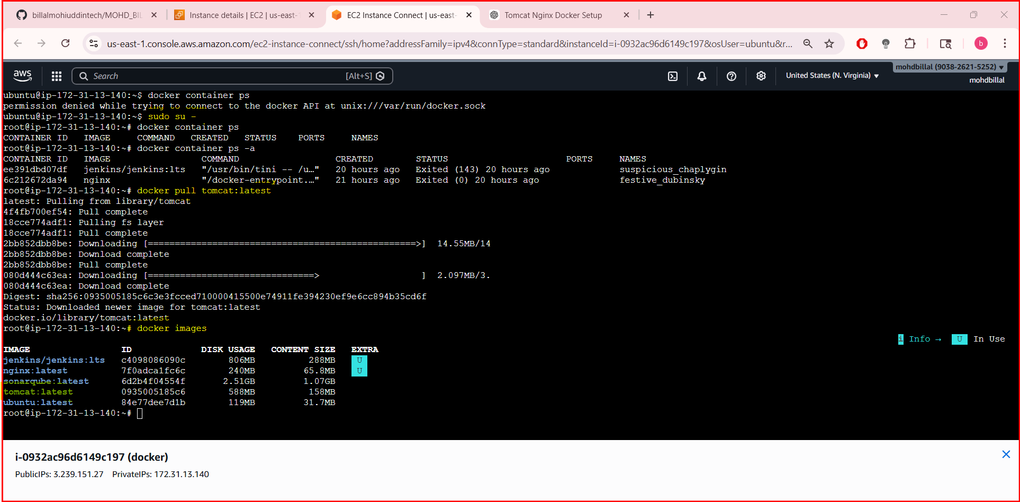
- Run the container with port number 8080 in background

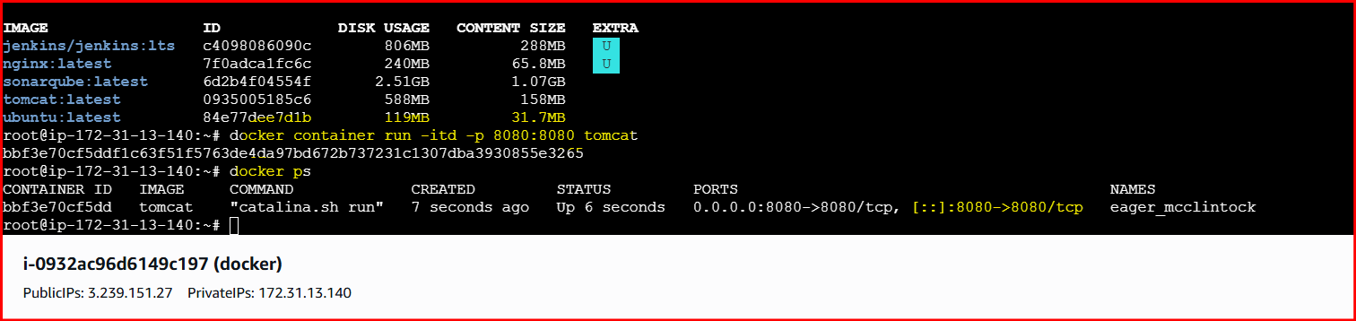
- Verify in browser using publicip@portnumber
- Here we got an error like 404 not found it because there is no sample file available for deployment

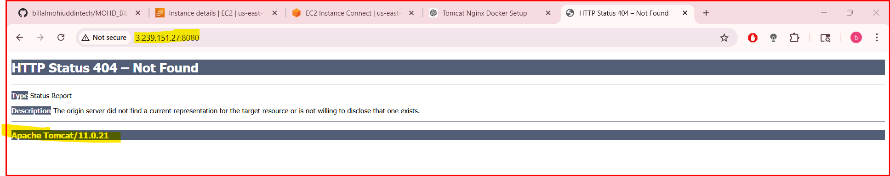
- Then search for a sample file and copy the link

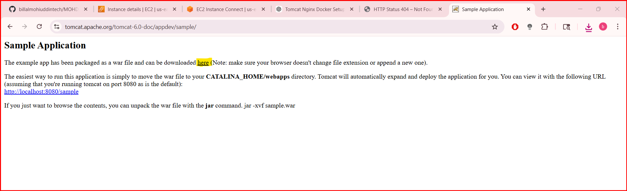
- Get inside of tomcat container and perform the actions

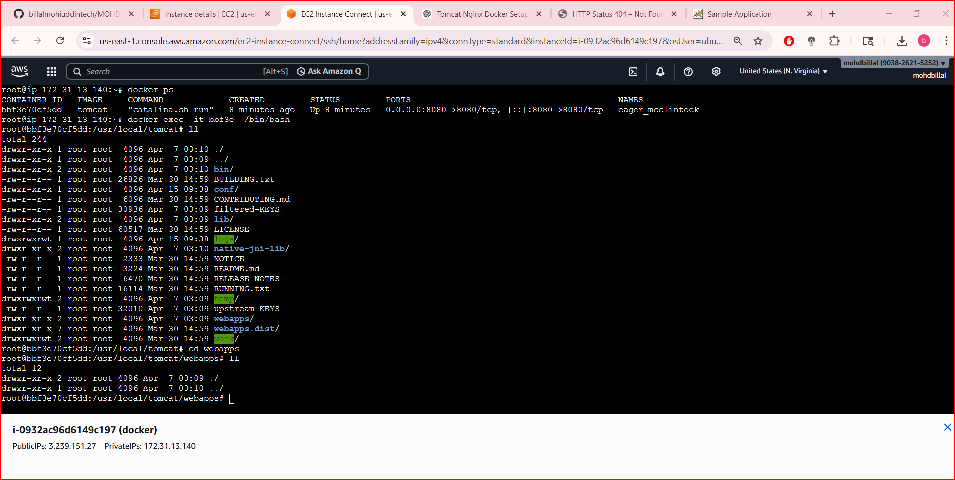

- If you face any error regarding command not found then install the command like wget
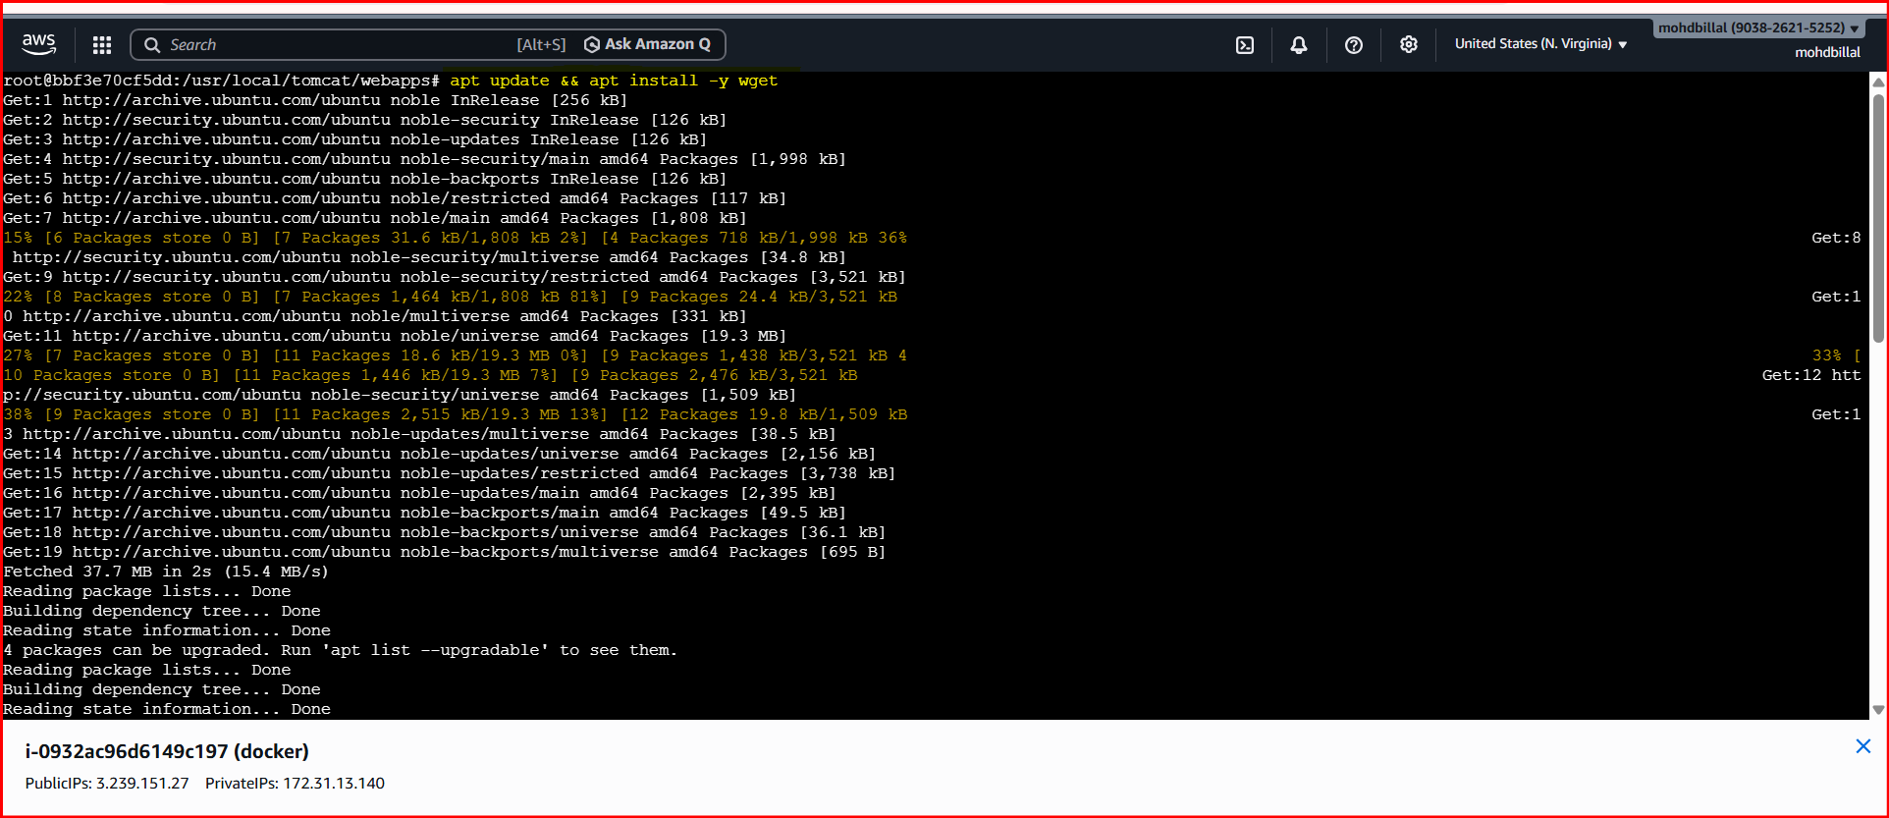
- Then download the sample.war file and wait for few seconds to unzip the file it automatically does

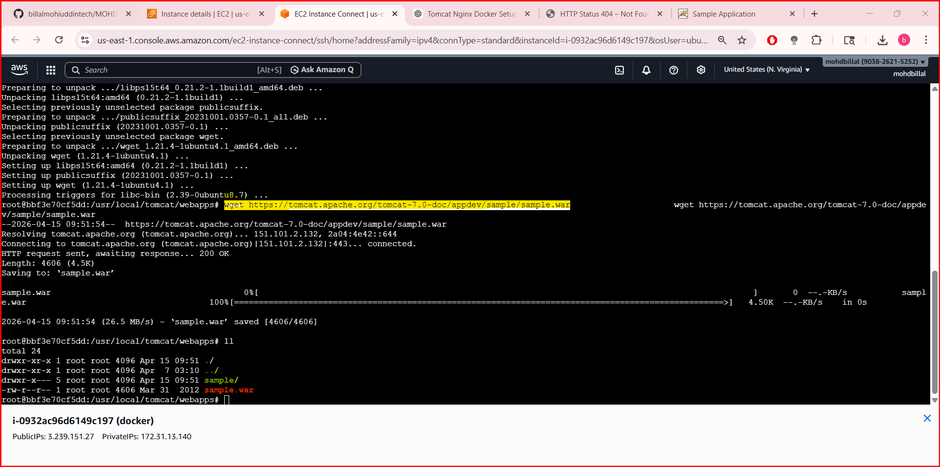
- Later verify on web using /sample
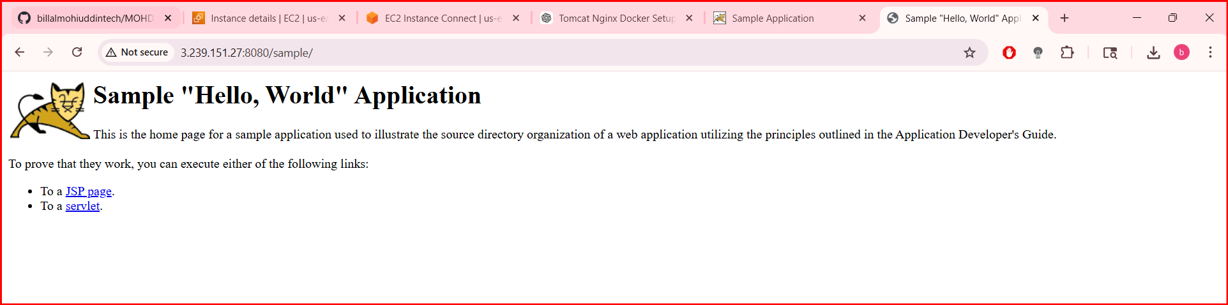
- A Tomcat container was successfully created on port 8080, and a sample application was deployed and verified, confirming that the Tomcat server is running and serving applications correctly

- Create volume and deploy tomcat container on port 8081.

- To create a Docker volume for persistent storage and deploy a Tomcat container on port 8081 using that volume.
- Bonus:
- If u need to customize or change the name of image then you can use the below command

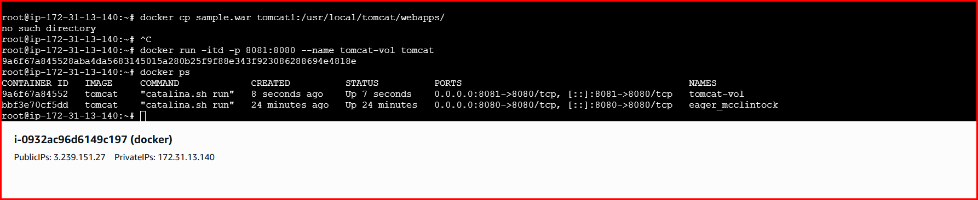
- Step by Step Implementation:
- Create a volume naming as prod
- And verify the volumes using ls command
- Get into the dir using default path of volumes and get inside of it
- Inside of _data dir download the sample.war file
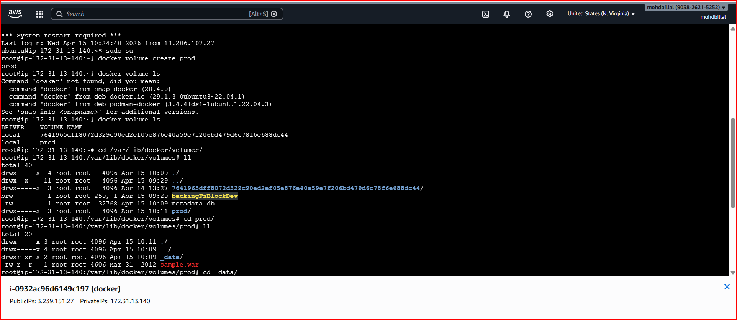
- And verify using ll
Now run the command by providing full path and verify on browser
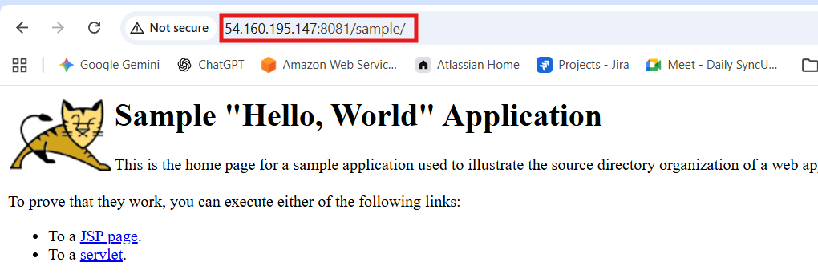
- A Docker volume was created to provide persistent storage, and a Tomcat container was deployed using that volume and exposed on port 8081. This ensures that application data inside Tomcat remains intact even if the container is stopped or recreated.
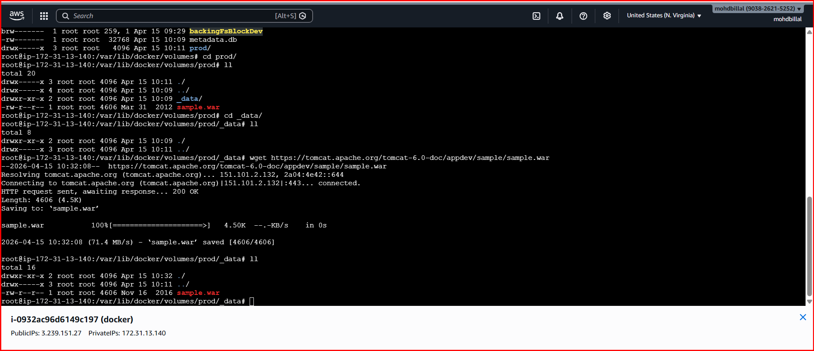
- Limit the nginx container to 500 MB.
- To run an Nginx container with its memory usage limited to 500 MB.
- Step by Step Implementation
- Use the command to start the container with memory limit
- Docker container run -itd -p 82:80 –memory 500m nginx

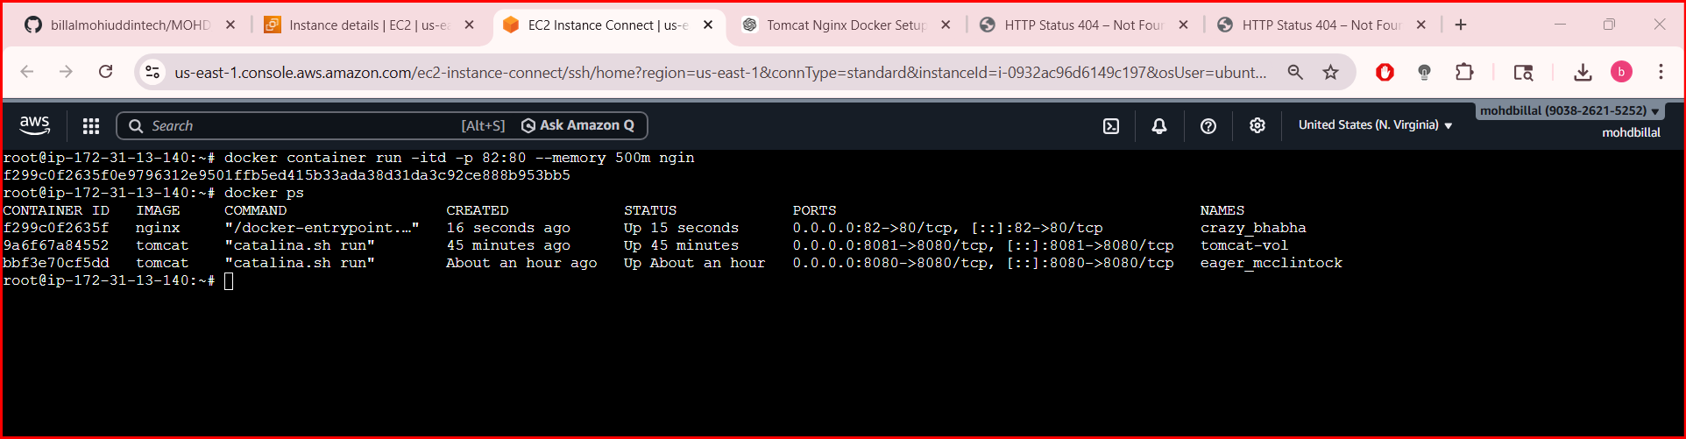
- Using the docker ps verify the container id and check the space
- Use the command docker stats to check the memory

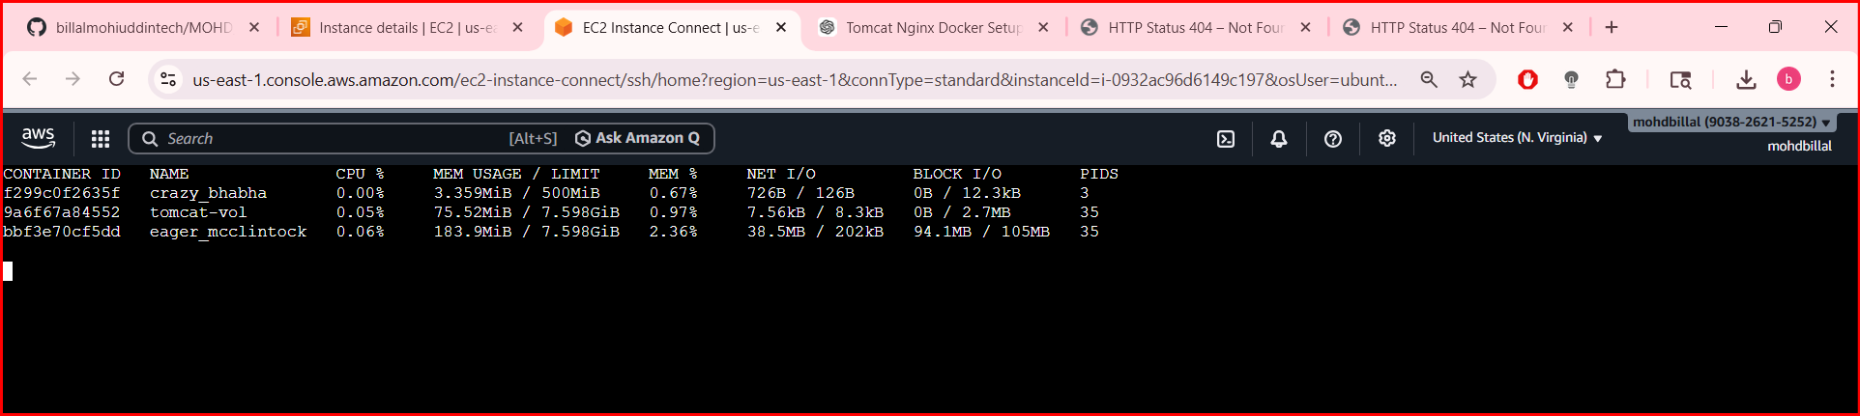
Conclusion :
- The Nginx container was successfully deployed with a 500 MB memory limit, ensuring controlled resource usage and preventing excessive memory consumption.

- Create a sample docker file using below instructions.
- Base module as amazonlinux:latest
- Maintainer you name
- Install nginx
- COPY one index.html file to image
- Expose on port 80
- Command to start the nginx container
To create a Docker image using amazonlinux:latest, install Nginx, copy a sample index.html file, and configure the container to run Nginx on port 80.
Implementation:
- Step 1: Create index.html
- Step 2: create Dockerfile and insert the data

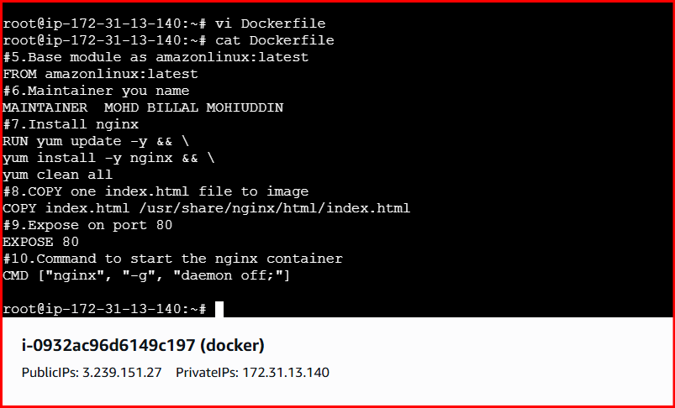
Syntax::
#5.Base module as amazonlinux:latest
FROM amazonlinux:latest
- #6.Maintainer you name
- MAINTAINER MOHD BILLAL MOHIUDDIN
- #7.Install nginx
- RUN yum update -y && \
- yum install -y nginx && \
- yum clean all
- #8.COPY one index.html file to image
- COPY index.html /usr/share/nginx/html/index.html
- #9.Expose on port 80
- EXPOSE 80
- #10.Command to start the nginx container
- CMD ["nginx", "-g", "daemon off;"]
- After that execute the command docker build -ty amazon-nginx and it will download
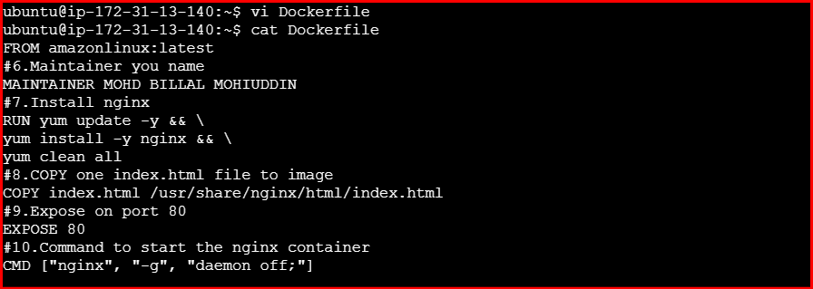
- After that execute the command docker build -ty amazon-nginx and it will download

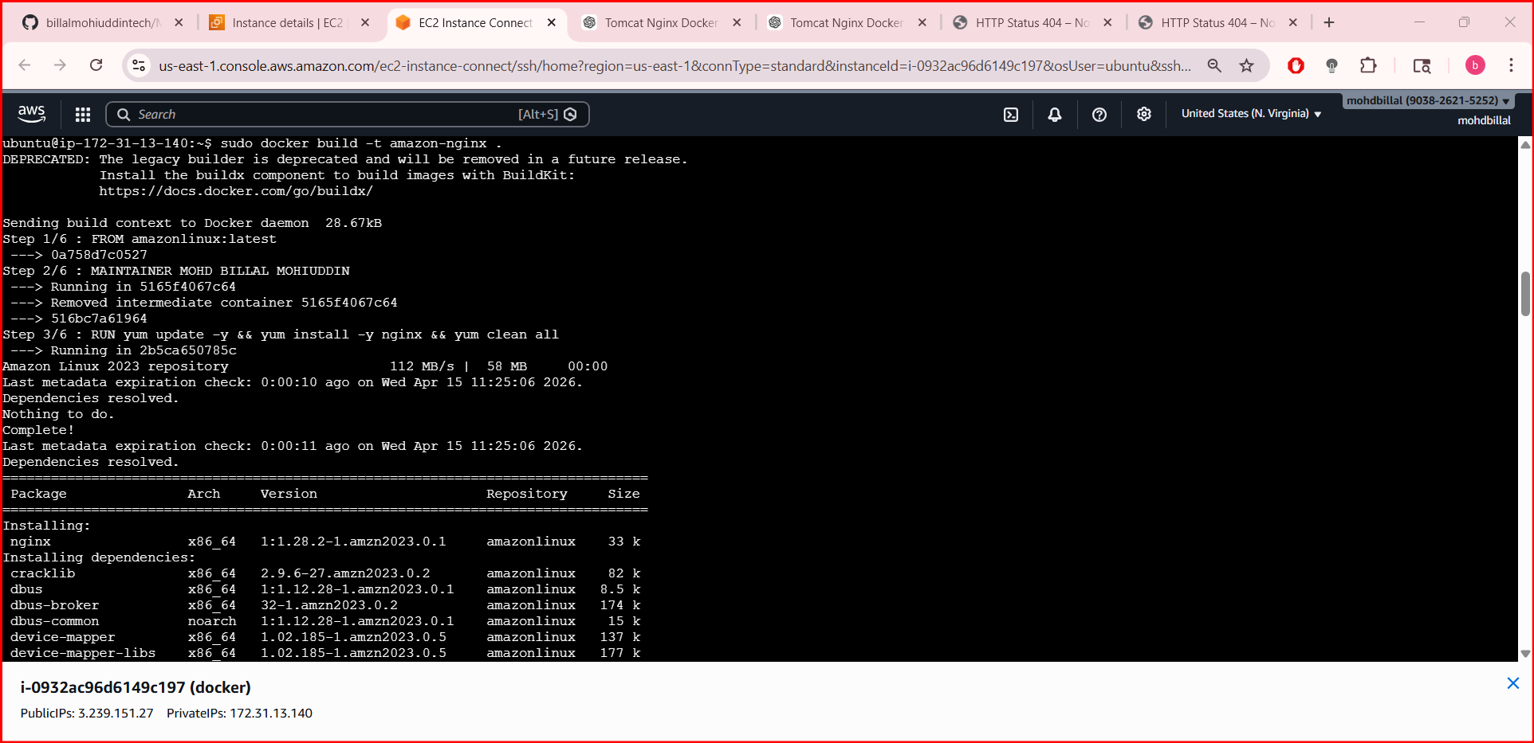
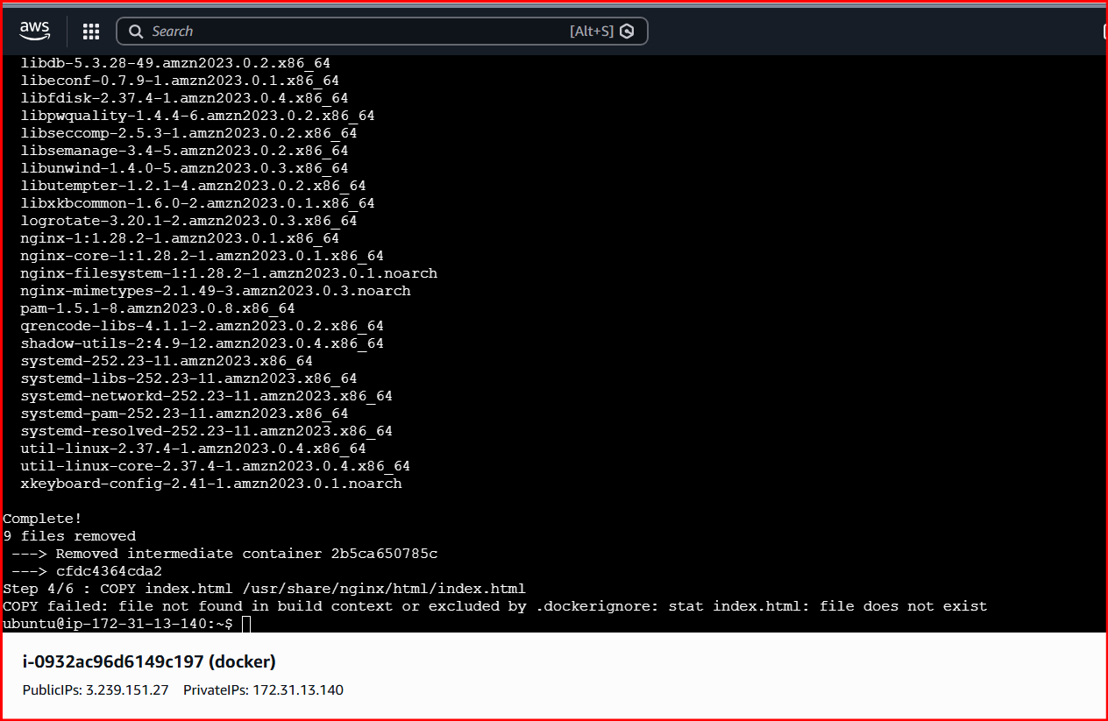
- Running again nginx on port 83 and verified in browser

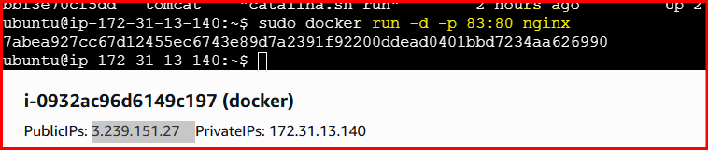
Verify it in browser.
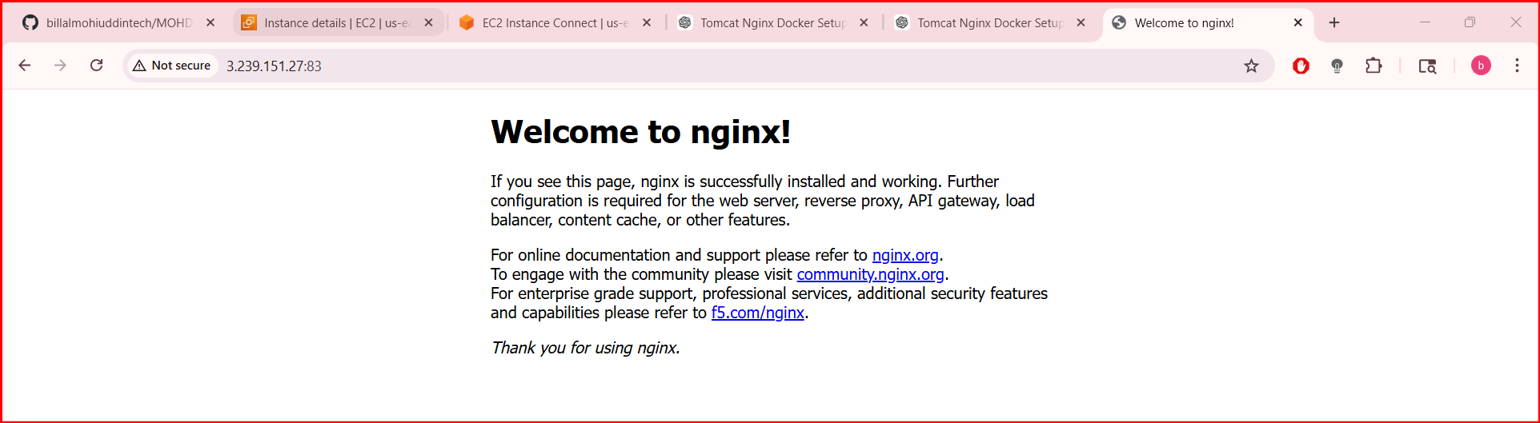
- A custom Docker image was successfully built with Amazon Linux and Nginx, serving a static index.html page on port 83, demonstrating basic Dockerfile creation and containerized web hosting.

- Push image to Docker hub
- To tag and push a Docker image to Docker Hub for storage and reuse.
- Step By Step Implementation:
- Login to docker hub in browser and create a account

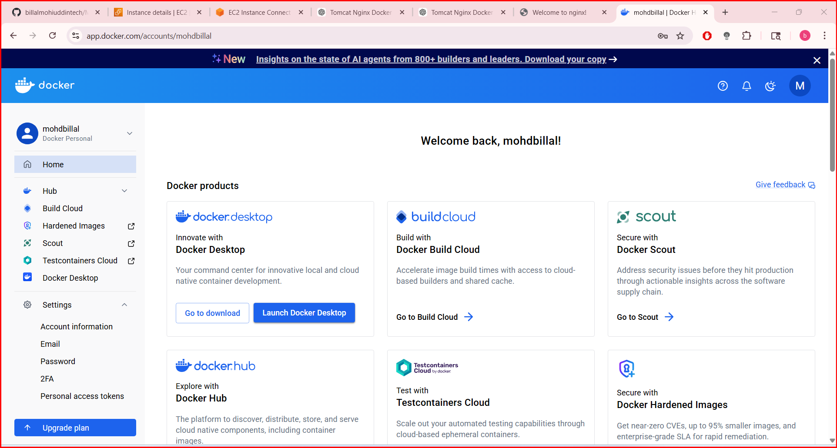
- After that create a custom repository

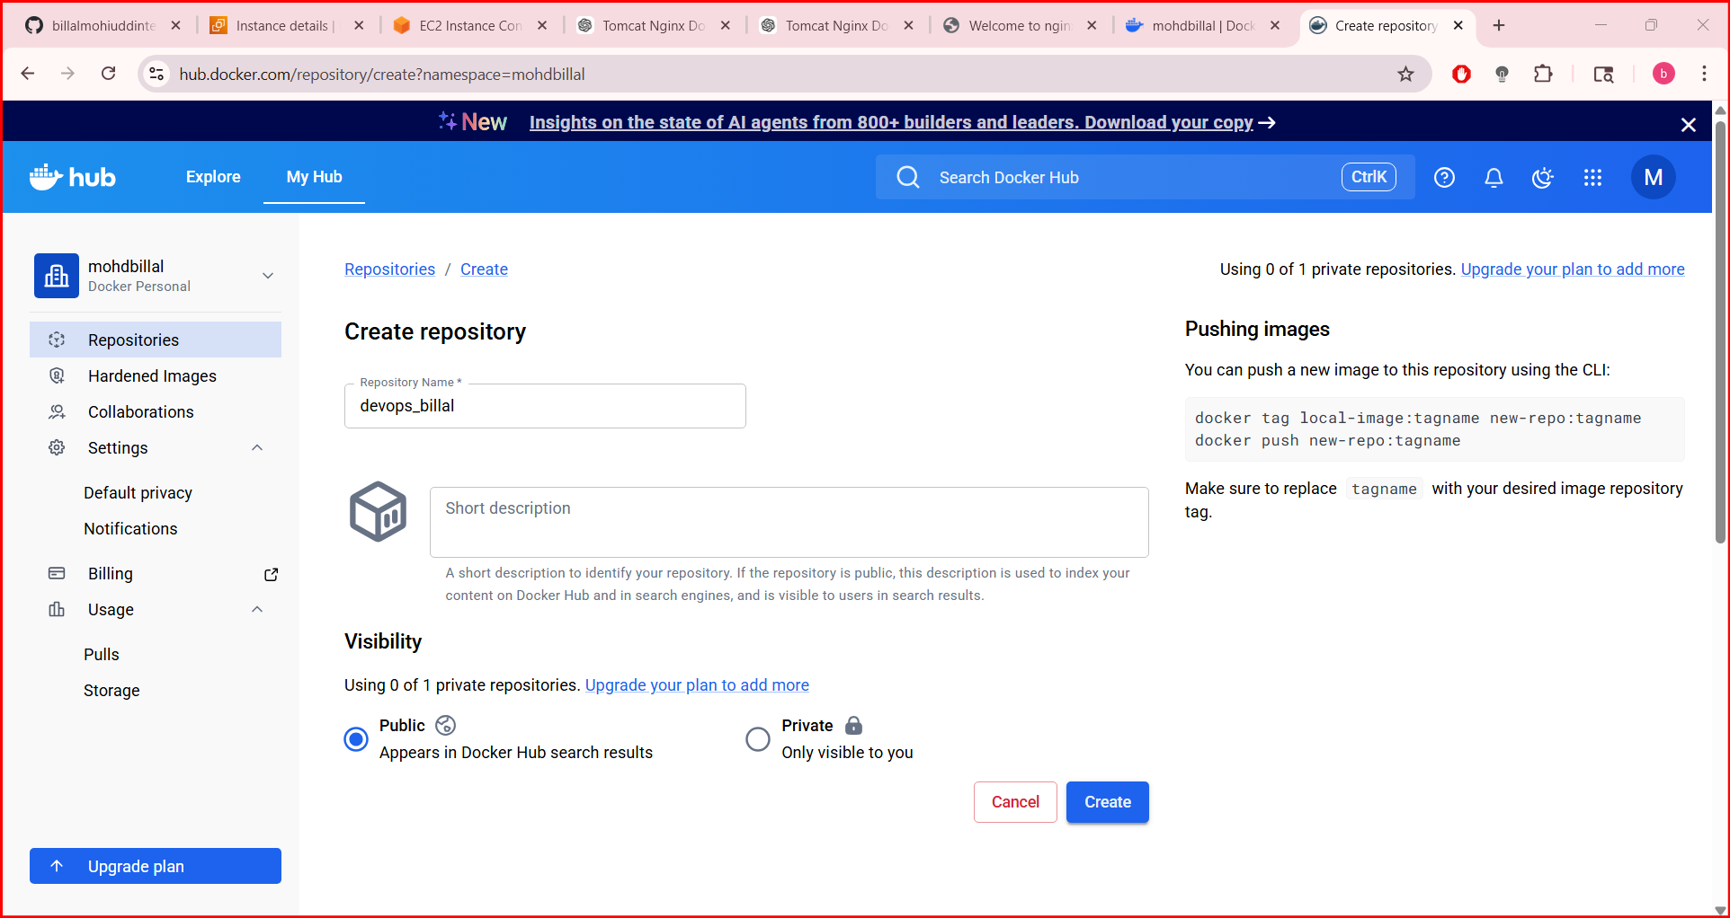
- After that perform docker login in server for integrating

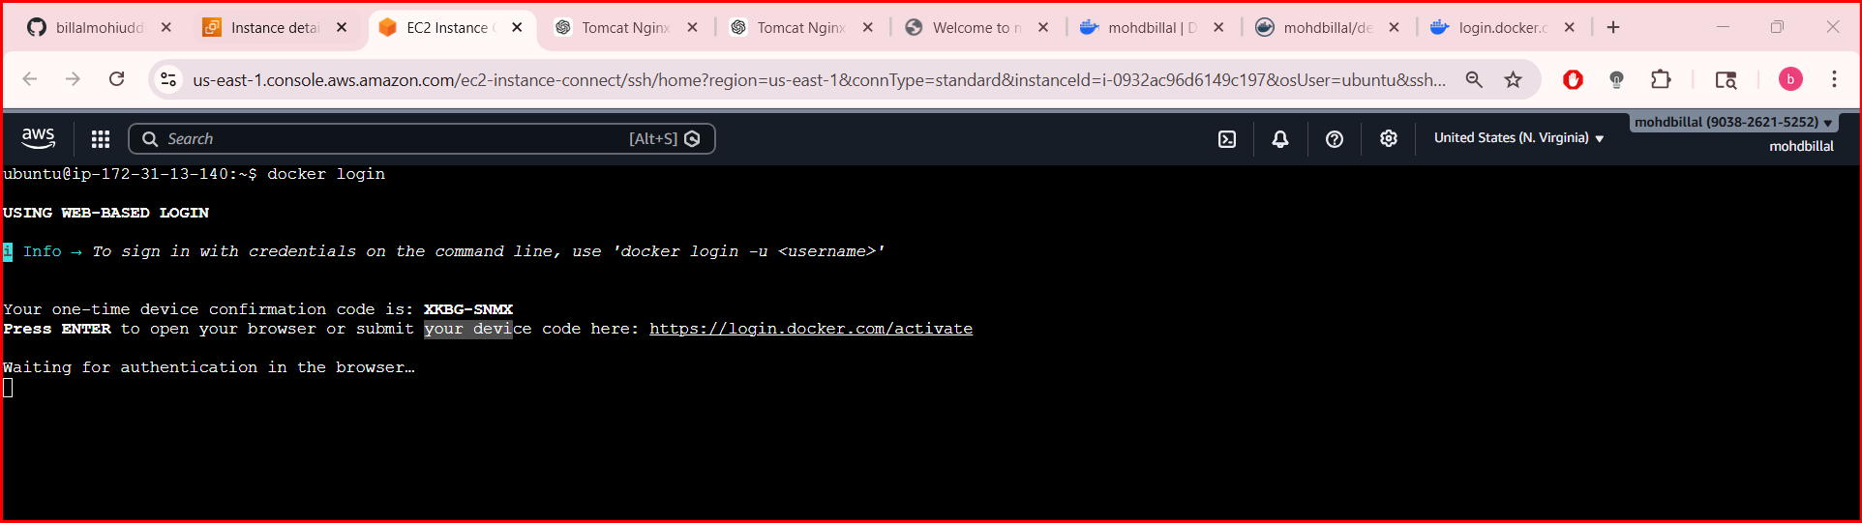
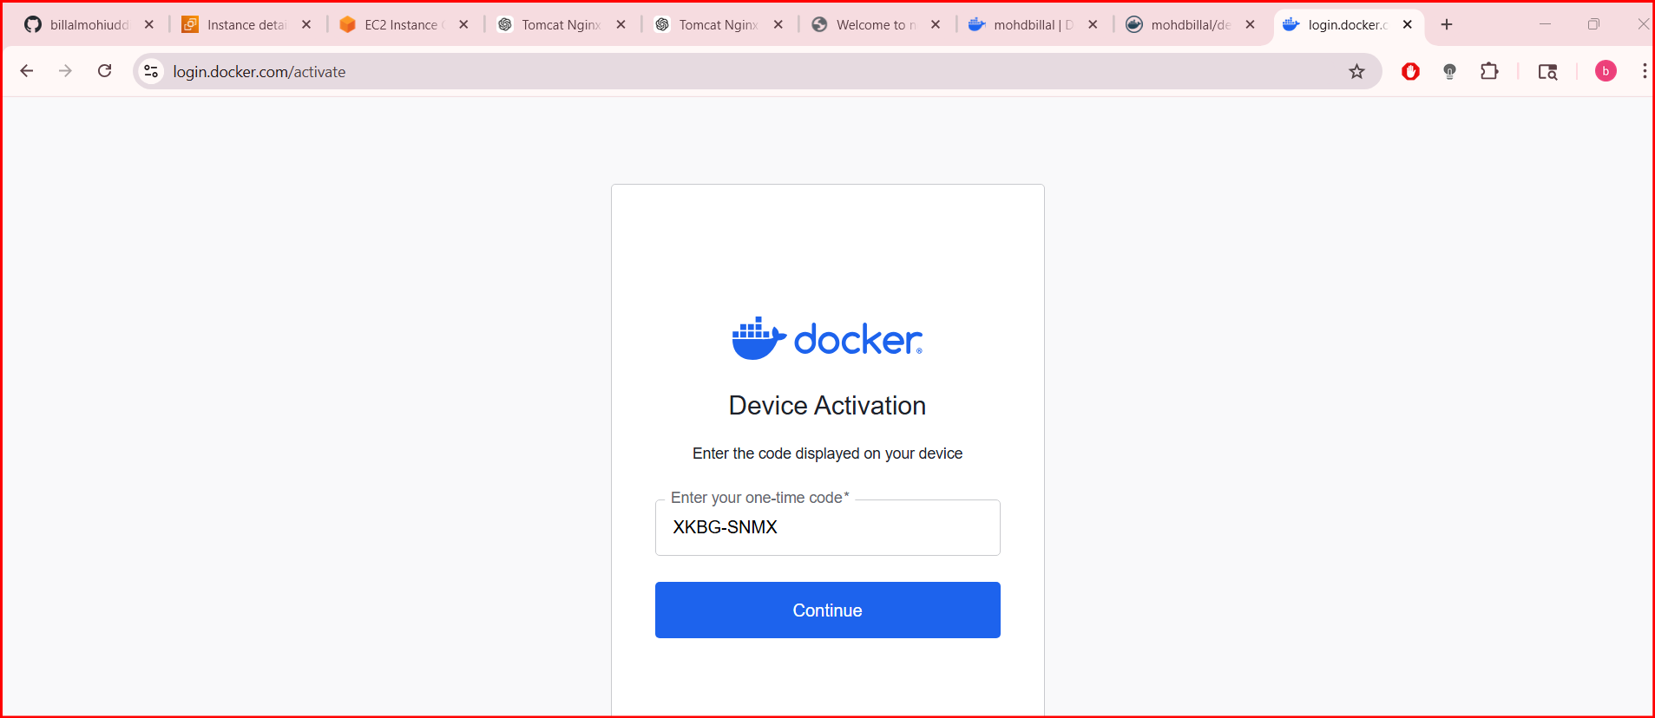
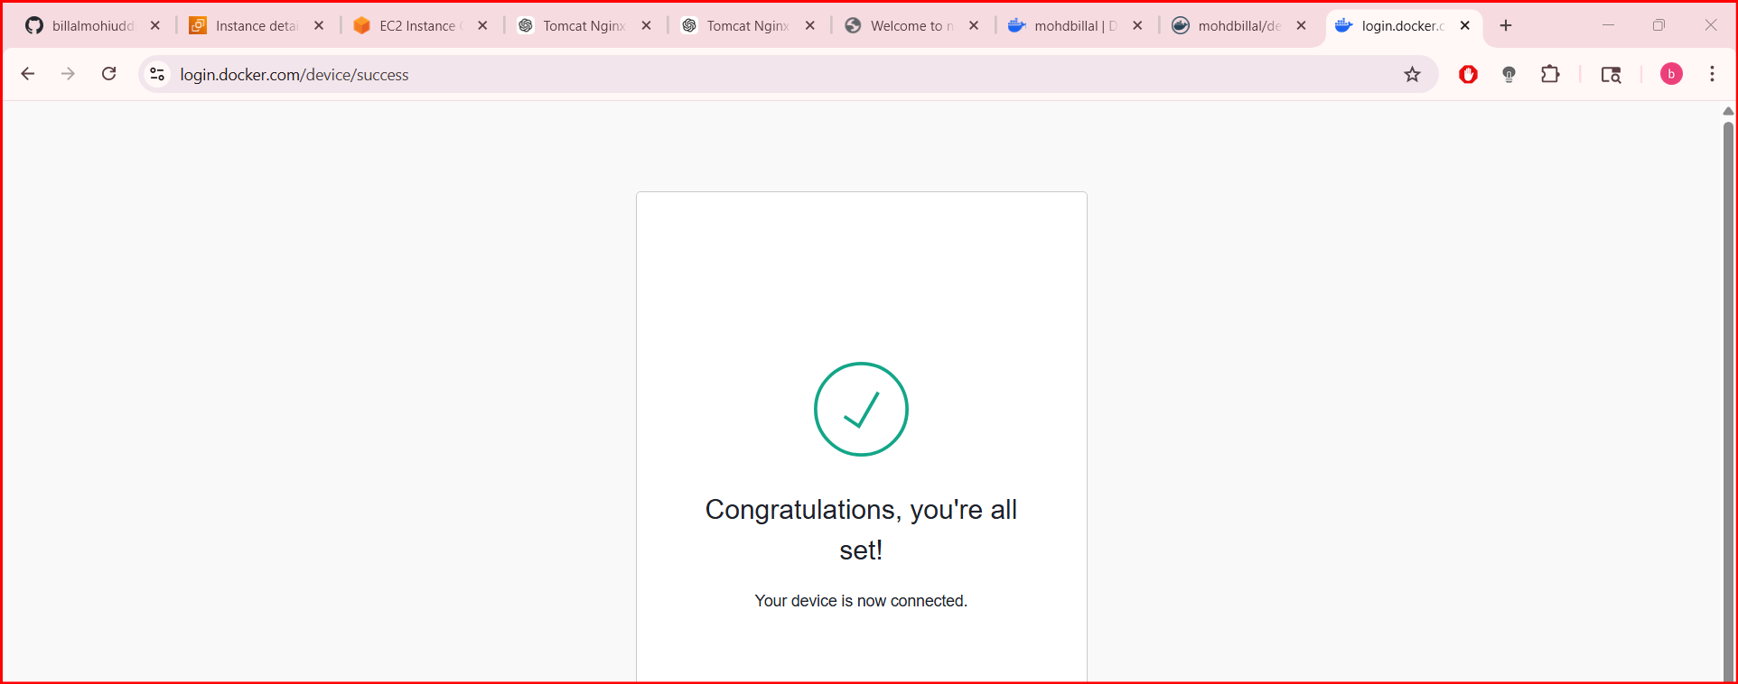
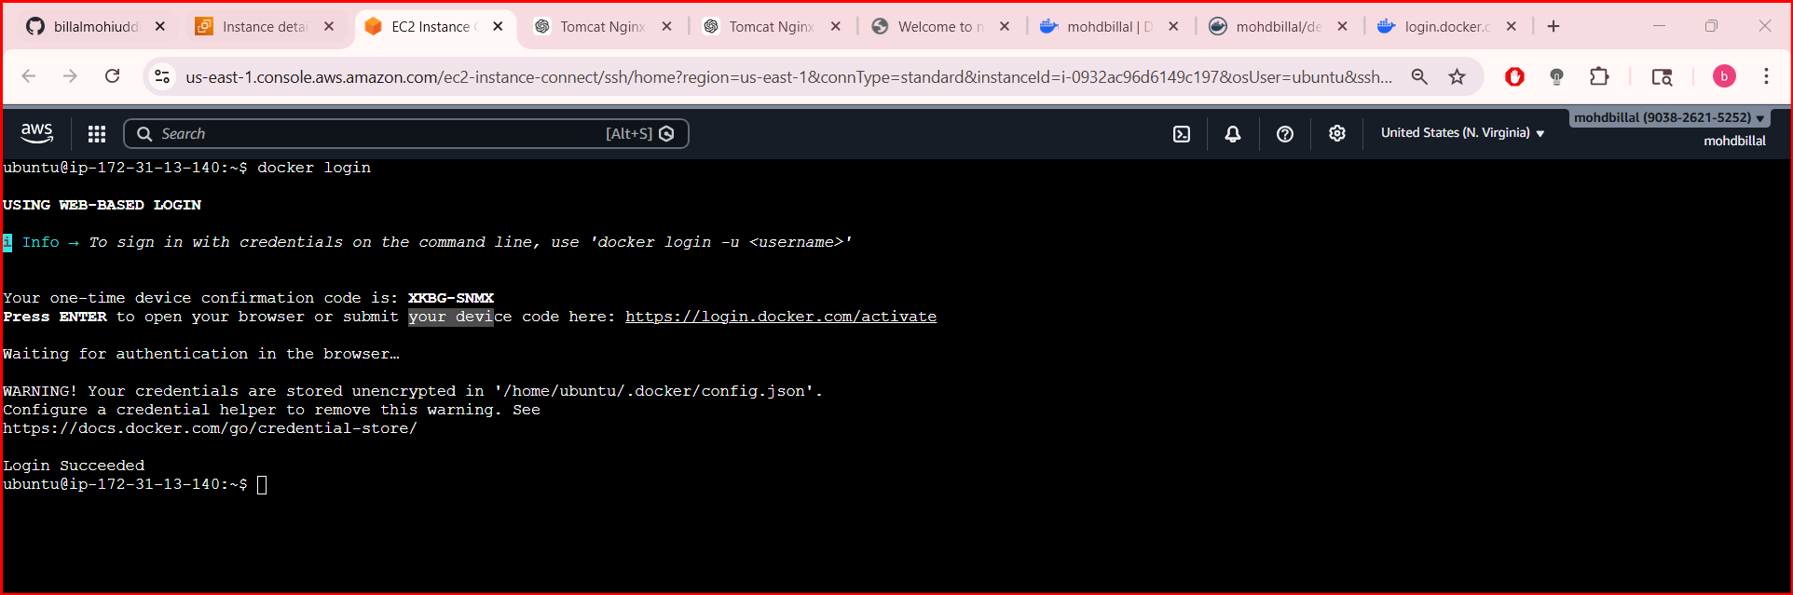
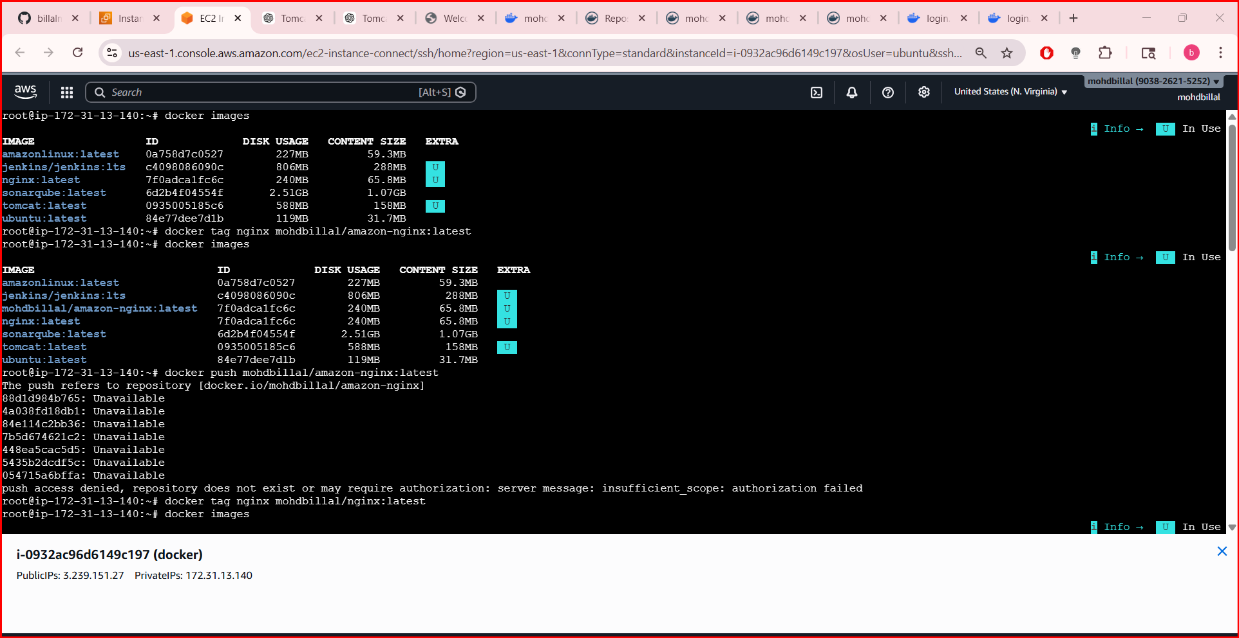
Login through root
- Docker ps
- Then docker push

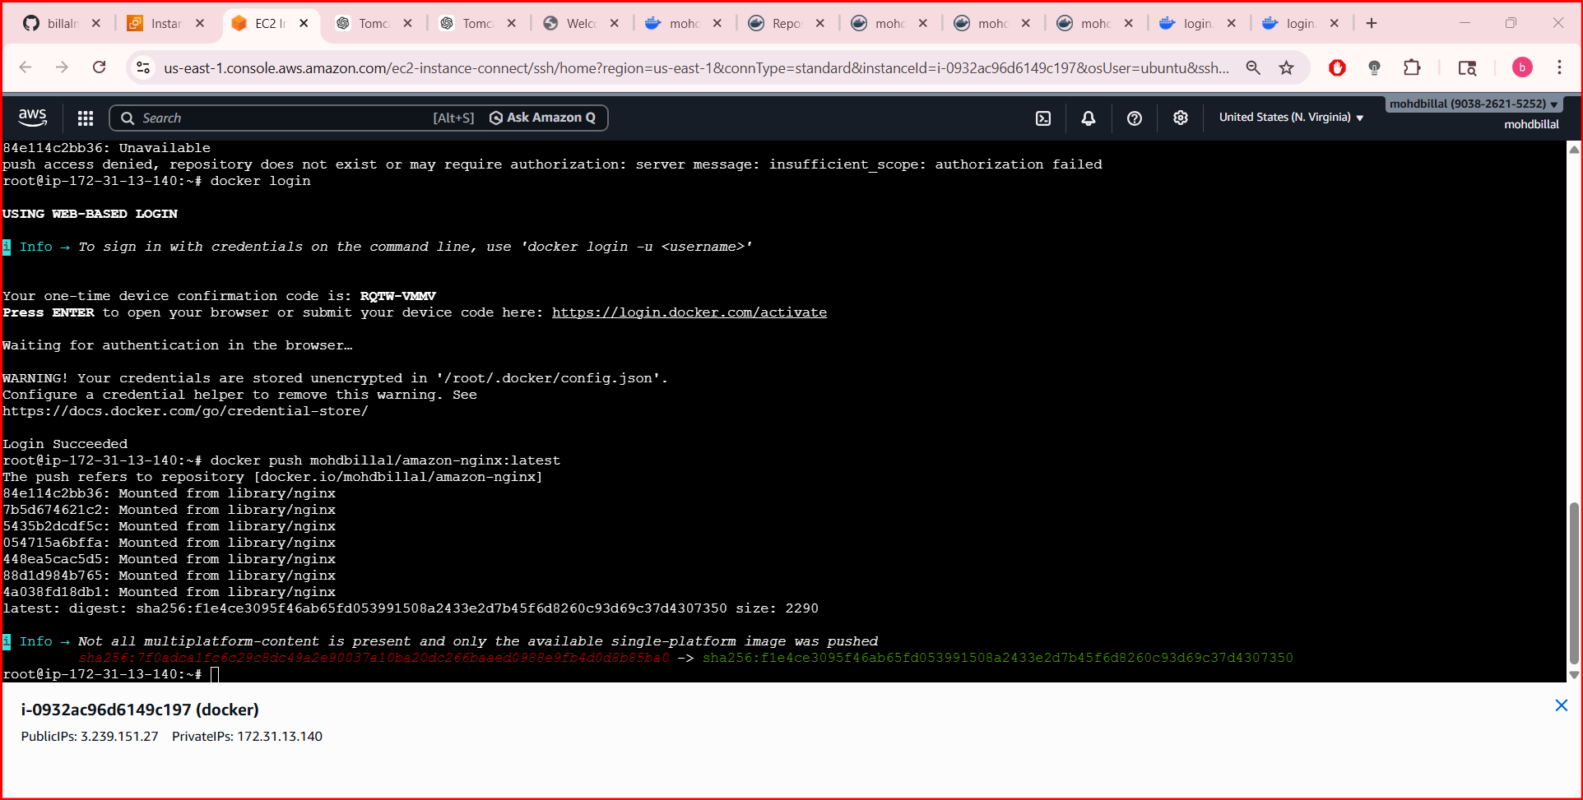
- The Docker image was successfully pushed to Docker Hub, making it available for sharing, deployment, and reuse across different environments
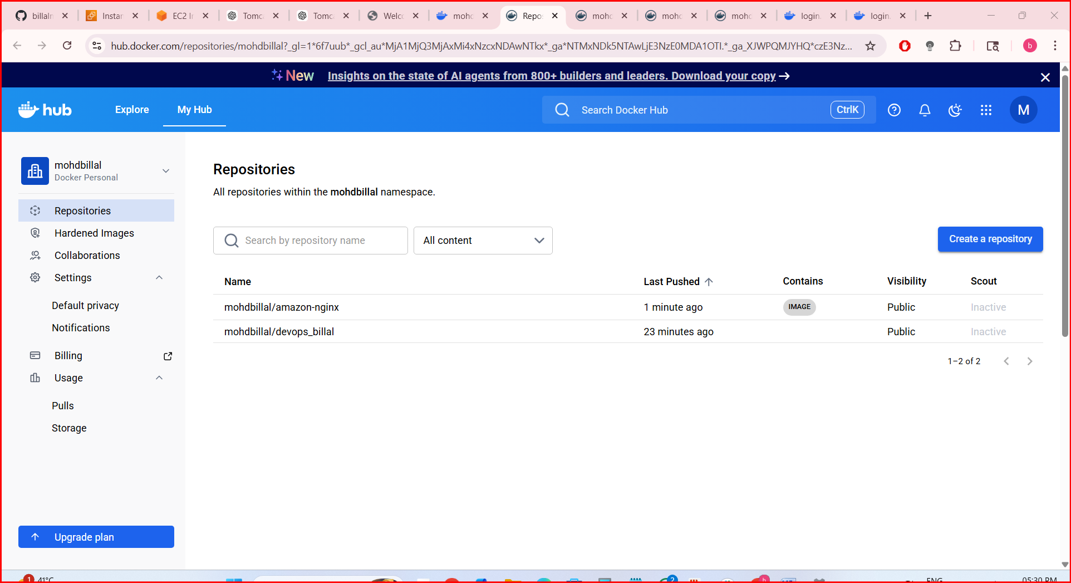

- push image to AWS ECR
- To push a Docker image to AWS ECR (Elastic Container Registry) for secure storage and use within AWS services.
- Step by Step Implementation:
- Navigate to ecr and create a repository

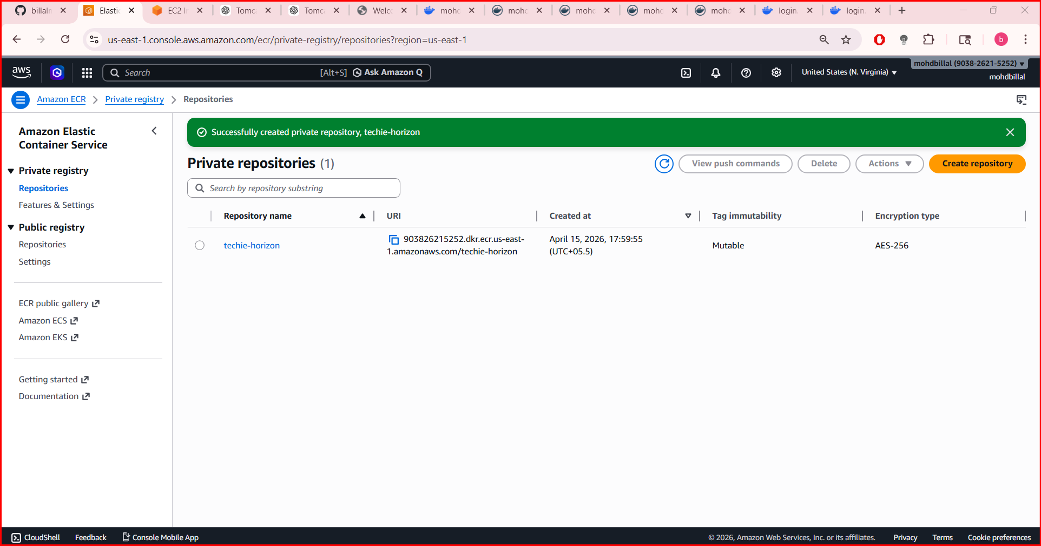
- Perform aws configure
- aws ecr get-login-password --region us-east-1 \
- | docker login --username AWS --password-stdin 783016426836.dkr.ecr.us-east-1.amazonaws.com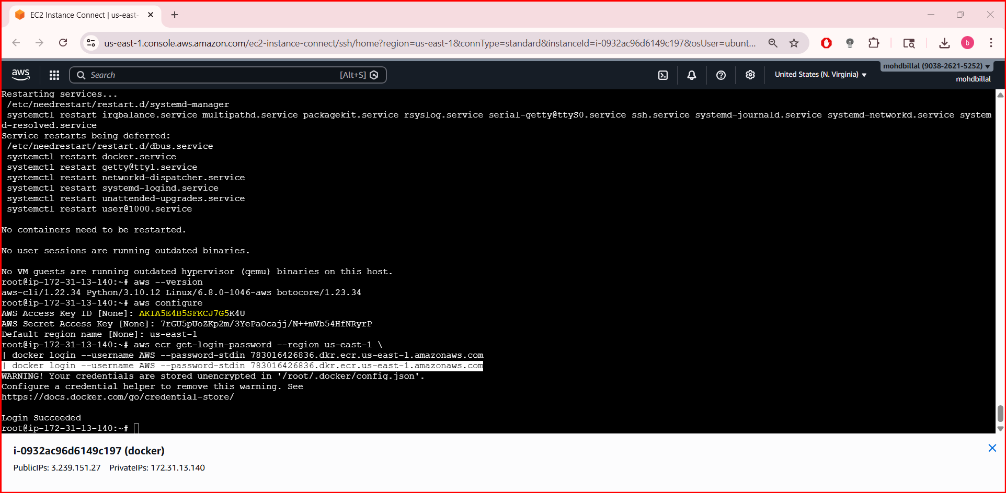
Tag your image for ECR
- docker tag amazon-nginx:latest 783016426836.dkr.ecr.us-east-1.amazonaws.com/devops:latest
- Push image to AWS ECR
- docker push 783016426836.dkr.ecr.us-east-1.amazonaws.com/devops:latest

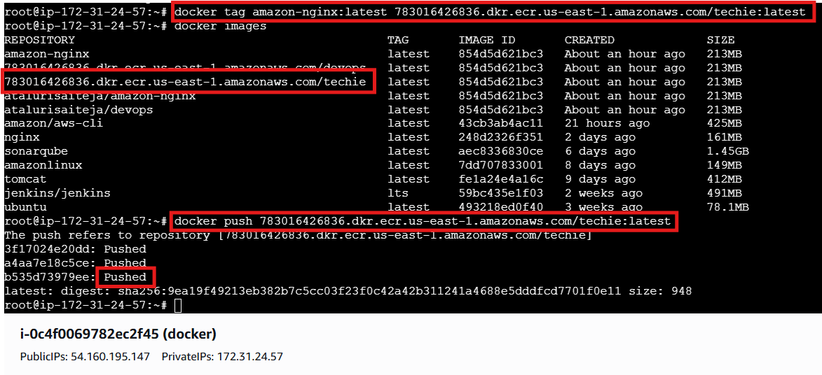
Verify
aws ecr list-images --repository-name devops --region us-east-1
